Funnel plots:
Supplementary Figure 1. Funnel plot (random (A) and fixed (B) effects models) for the comparison of GDM prevalence during pandemic and pre-pandemic cohorts. GDM, gestational diabetes mellitus.

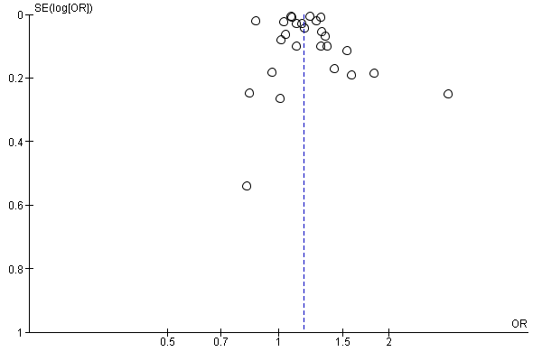
Fig. 1.A
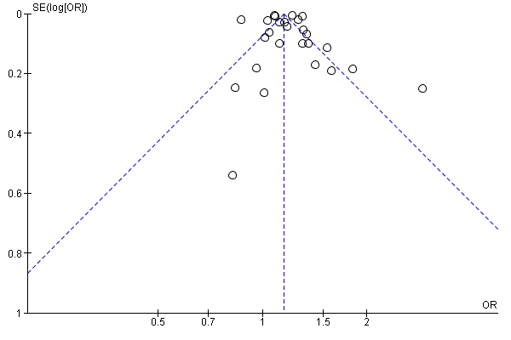
Fig. 1.B

