Supplementary Figure 2. Funnel plots (random (A) and fixed (B) effects models) regarding COVID-19 as a risk factor for GDM. COVID-19, coronavirus disease 2019.

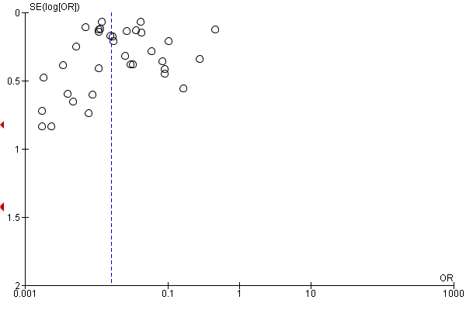
Fig. 2.A

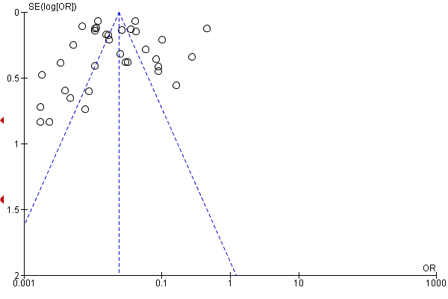
Fig. 2.B

